Judul : Membuat segitiga nested

Nama : Nurul Ulfa Ashilah

NIM : J3C117068

**TUGAS**

Form :

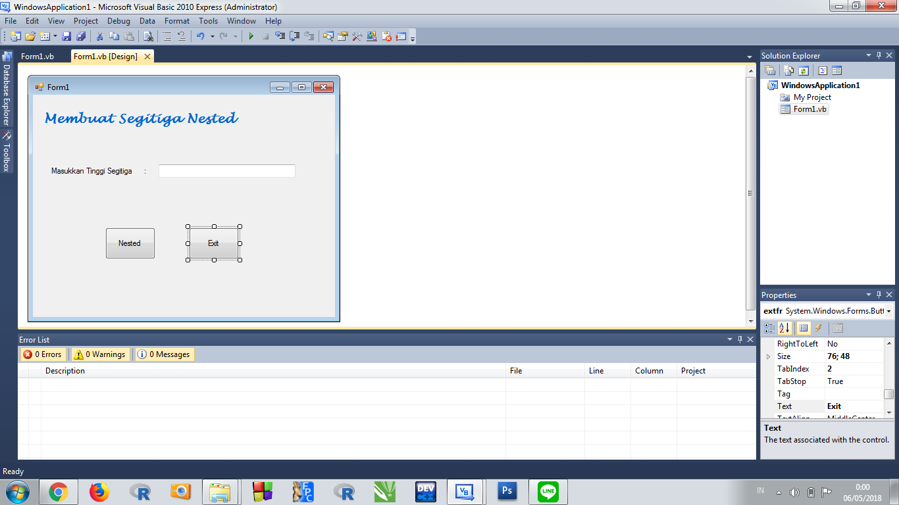

Saat dimasukkan nilai :

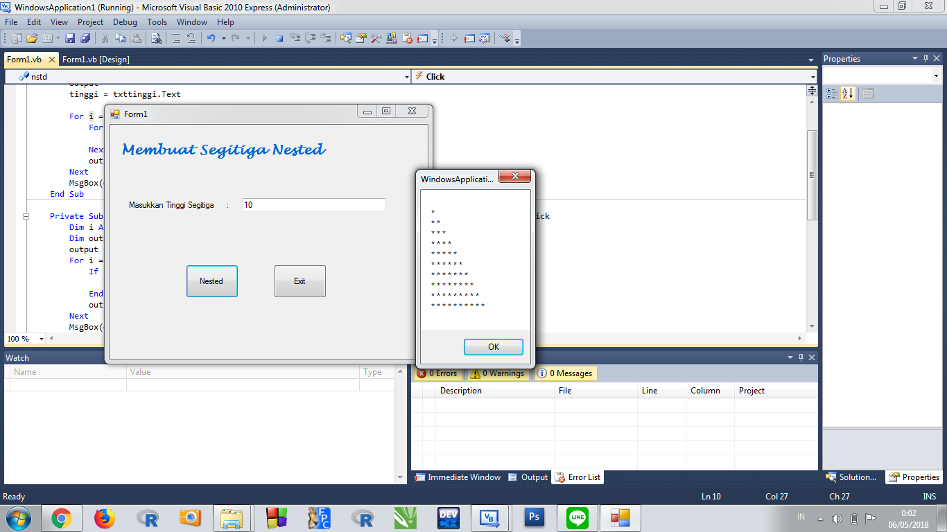

Program :

Public Class Form1

Private Sub nstd_Click(ByVal sender As System.Object, ByVal e As System.EventArgs) Handles nstd.Click

Dim i, j, tinggi As Integer

Dim output As String

output = ""

tinggi = txttinggi.Text

For i = 0 To tinggi - 1

For j = 0 To i

output = output & " " & "*"

Next

output = output & vbCrLf

Next

MsgBox(output)

End Sub

Private Sub extfr_Click(ByVal sender As System.Object, ByVal e As System.EventArgs) Handles extfr.Click

Dim i As Integer

Dim output As String

output = ""

For i = 0 To 10

If i = 3 Then

Exit For

End If

output = output & " " & i

Next

MsgBox(output)

End Sub

End Class